## VBay online Auctions

First things first, before jumping into answering questions, I like to get familiar with the objects/tables and how they are connected.

Show all the tables to get familiar:

All bids

Item type look-up table

All Items

All user ratings

All users

All user zip-codes

Filter to only show collectables

Project to show **item_name, item_type, item_reserve, and** **item_soldamout** for collectables

Sort previous output by item name

Now let’s start looking at the seller’s information for the antiques. Let’s join **vb_items** and **vb_users** to determine who are the sellers of all items

**output too large to display all results**

Filter rows to show sellers of antiques



Project only the columns needed for previous output

Now let’s join the items table to the user’s table *twice* to show both buyers and sellers’ information for each item

**wide output, two screenshots attached**

select *

from vb_items as i

join vb_users as s on s.user_id = i.item_seller_user_id

join vb_users as b on b.user_id = i.item_buyer_user_id;

Join users’ tables twice to show the buyers and sellers for each item sold labeled appropriately, along with the difference between **item_reserve** amount and **item_soldamount** to show the profit/loss margin

**wide output, two screenshots attached**

select s.user_email as sellers_email,

b.user_email as buyers_email,

i.item_soldamount - i.item_reserve as item_margin,

i.*

from vb_items as i

join vb_users as s on s.user_id = i.item_seller_user_id

join vb_users as b on b.user_id = i.item_seller_user_id

where item_sold >= 1;

--Sort with highest margin first

select s.user_email as sellers_email,

b.user_email as buyers_email,

i.item_soldamount - i.item_reserve as item_margin,

i.*

from vb_items as i

join vb_users as s on s.user_id = i.item_seller_user_id

join vb_users as b on b.user_id = i.item_buyer_user_id

where i.item_sold = 1

order by item_margin DESC;

Sales would like to send mailings to users who live in a zip code that starts with ‘13’, for example 13244, so they can be notified of their new contact in that region.

select *

from vb_users

where user_zip_code like '13%';

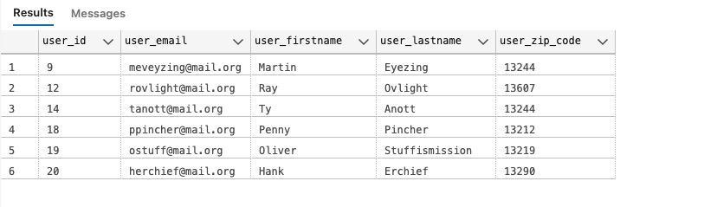

Find all users from state of NY. Print their names, emails, city, state, and zip code.

Sort by city, then user’s last/first name.

select u.user_email, u.user_firstname, u.user_lastname, z.zip_city, z.zip_state, z.zip_code

from vb_users as u

join vb_zip_codes as z on u.user_zip_code = z.zip_code

where z.zip_state = 'NY'

order by z.zip_city, u.user_lastname, u.user_firstname;

High-priced items: Return the ID, name, type, and reserve of items that have not been sold and have a reserve of 250 or higher. Sort by city, then by user's last/first name

select item_id, item_name, item_type, item_reserve

from vb_items

where item_sold = 0

AND item_reserve >= 250

order by item_reserve DESC;

Reserve item categories. Include the ID, name, type, and reserve price of the item. Do not include items of type “All Other”. Create a category column based on item reserve price.  
When the item is 250 or more, it is a high-priced item.  
When the item is 50 or less, it is a low-priced item.  
Everything else is an average-priced item.

select item_id, item_name, item_type, item_reserve,

case when item_reserve >= 250 then 'high-priced item'

when item_reserve <=50 then 'low-priced item'

else 'average-priced item'

end as reserve_item_category

from vb_items

where NOT item_type = 'All Other';

Write a query that displays the valid user bids (bid status of ‘ok’) for a given **item_id**. This  
would commonly be displayed on the website for the chosen item. You select the item ID to display and show the bid ID, bid user’s name, bid user email, bid date, and bid amount. Put the most recent bids at the top.

select b.bid_id, b.bid_item_id, u.user_firstname, u.user_lastname, u.user_email, bid_datetime, b.bid_amount, b.bid_status

from vb_bids as b

join vb_users as u

on b.bid_user_id = u.user_id

where b.bid_status='ok'

order by bid_datetime DESC;

The bad bidder list. Write a query to help the security audit team find fraudulent activity. For any bid that does not have a status of ‘ok’, include the date of the bid, name, email, and ID of the bidder and the name and ID of the item bid upon. Also include the amount of the bid and bid status. Sort the output by the user name (last, then first) and then by bid date for users with multiple bad bids.

select b.bid_datetime,u.user_firstname, u.user_lastname, u.user_email, u.user_id, i.item_name, i.item_id, b.bid_amount, b.bid_status

from vb_bids as b

join vb_users as u

on b.bid_user_id = u.user_id

join vb_items as i

on b.bid_item_id = i.item_id

where NOT bid_status= 'ok'

order by u.user_lastname, u.user_firstname, b.bid_datetime;

Product a report of items that do not contain a bid. Include the item ID, item name item type, seller’s name, and item reserve.

select i.item_id,i.item_name, i.item_type,i.item_reserve, b.bid_status, concat(u.user_firstname, ' ', u.user_lastname) as seller_name

from vb_items i

left join vb_bids b

on i.item_id= b.bid_item_id

join vb_users u

on i.item_seller_user_id=u.user_id

where b.bid_status IS null;

Produce a list of seller ratings. Include the name of the user who gave the rating, the name of the user the rating was for, the rating value, and the rating comment. Include ratings of only sellers.

select concat(g.user_firstname, ' ', g.user_lastname) as rating_giver, concat(t.user_firstname, ' ', t.user_lastname) as person_rated,

r.rating_value, r.rating_comment, r.rating_astype

from vb_user_ratings r

join vb_users g

on r.rating_by_user_id = g.user_id

join vb_users t

on r.rating_for_user_id = t.user_id

where r.rating_astype='Seller';

For items that were sold, generate a report that includes the locations (city and state) of the buyer and seller. Include item ID, item name, item type, item sold amount, name of seller, seller’s city/state, name of buyer, and the buyer’s city/state.

select i.item_id, i.item_name, i.item_type, i.item_soldamount, concat(s.user_firstname, ' ', s.user_lastname) as seller_name,

concat(sz.zip_city,' ', sz.zip_state) as seller_city_state, concat(b.user_firstname, ' ', b.user_lastname) as buyer_name,

concat(bz.zip_city, ' ', bz.zip_state) as buyer_city_state

from vb_items i

join vb_users s

on i.item_seller_user_id=s.user_id

join vb_users b

on i.item_buyer_user_id=b.user_id

join vb_zip_codes sz

on s.user_zip_code=sz.zip_code

join vb_zip_codes bz

on b.user_zip_code=bz.zip_code;

Users with no activity. Find the names and emails of any users who have never posted an item for bid or have never bought the item or have never placed a bid.

select u.user_firstname, u.user_lastname, u.user_email, bi.item_buyer_user_id,si.item_seller_user_id, bd.bid_user_id

from vb_users u

left join vb_items si

on si.item_seller_user_id=u.user_id

left join vb_items bi

on bi.item_buyer_user_id=u.user_id

left join vb_bids bd

on bd.bid_user_id=u.user_id

where bi.item_buyer_user_id is null

and si.item_seller_user_id is null

and bd.bid_user_id is null;

For all items, include the name of the item, the reserve price, the lowest bid, highest bid, and sold amount. Put items with the largest reserve first.

select item_name, item_reserve, min(bid_amount) as min_bid,

max(bid_amount) as max_bid, item_soldamount

from vb_items

join vb_bids on item_id=bid_item_id

where bid_status = 'ok'

group by item_name, item_reserve, item_soldamount

order by item_reserve desc;

Show info with a count of bids including rows with no bids

select s.user_email, s.user_firstname, s.user_lastname, count(*) as bid_counts

from vb_users s

left join vb_bids b

on b.bid_user_id=s.user_id

where b.bid_status = 'ok'

group by s.user_email, s.user_firstname, s.user_lastname;

vBay! would like to classify their users based on the numbers of valid bids they have placed.

Low Activity = 0 or 1 bids  
Moderate Activity = 2 to 4 bids  
High Activity = 5 or more bids  
Then they would like to produce a report counting the number of users who fall into low, moderate, and  
high activity categories.

select s.user_email, s.user_firstname, s.user_lastname, count(*) as bid_counts,

case when count(*) between 0 and 1 then 'Low'

when count(*) between 2 and 4 then 'Moderate'

else 'High' end as user_bid_activity

from vb_users s

left join vb_bids b

on b.bid_user_id=s.user_id

where b.bid_status = 'ok'

group by s.user_email, s.user_firstname, s.user_lastname;

Produce Activity report from previous query by creating table using "WITH" statement to name query

with user_bids as (

select s.user_email, s.user_firstname, s.user_lastname, count(*) as bid_counts,

case when count(*) between 0 and 1 then 'Low'

when count(*) between 2 and 4 then 'Moderate'

else 'High' end as user_bid_activity

from vb_users s

left join vb_bids b

on b.bid_user_id=s.user_id

where b.bid_status = 'ok'

group by s.user_email, s.user_firstname, s.user_lastname

)

select *

from user_bids;

***same result as above***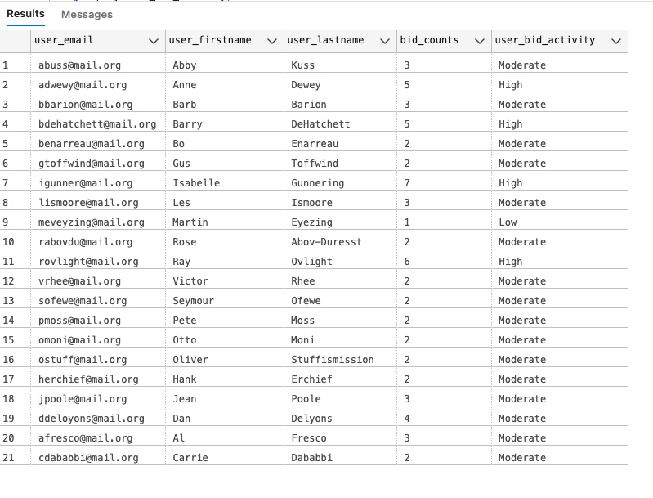

Using previous query as a table, count how many users for each **user_bid_activity** category sorted by user_count

with user_bids as (

select s.user_email, s.user_firstname, s.user_lastname, count(*) as bid_counts,

case when count(*) between 0 and 1 then 'Low'

when count(*) between 2 and 4 then 'Moderate'

else 'High' end as user_bid_activity

from vb_users s

left join vb_bids b

on b.bid_user_id=s.user_id

where b.bid_status = 'ok'

group by s.user_email, s.user_firstname, s.user_lastname

)

select user_bid_activity, count(*) as user_count

from user_bids

group by user_bid_activity

order by user_count;

How many item types are there? For each item type, provide the count of items, in that type, the min, average and max item reserve prices for that type. Sort output by item type

select

item_type,

count(item_type) as count_item_type,

min(item_reserve) as min_item_reserve,

AVG(item_reserve) as average_item_reserve ,

max(item_reserve) as max_item_reserve

from vb_items

group by item_type

order by item_type;

Perform an analysis of each item in the “Antiques” and “Collectables” item types. For each item,  
display the name, item type, and item reserve. Include the minimum, maximum, and average item  
reserve over each item type so that the current item reserve can be compared to these values.

select item_name, item_type, item_reserve,

min(item_reserve) over (partition by item_type) as min_item_reserve,

max(item_reserve) over (partition by item_type) as max_item_reserve,

avg(item_reserve) over (partition by item_type) as avg_item_reserve

from vb_items

where item_type in ('Antiques', 'Collectables');

Write a query to include the names, counts (number of ratings), and average seller ratings (as a  
decimal) of users. For reference, User Carrie Dababbi has four seller ratings and an average rating of  
4.75.

select i.item_name, count(*) as count_bids, i.item_type

from vb_items i

join vb_bids b on

i.item_id=b.bid_item_id

where item_type = 'Collectables'

group by i.item_name, i.item_type

having count(*) > 1

order by count(*) desc;

Create a list of “Collectable” item types with more than one bid. Include the name of the item and the number of bids, making sure the item with the most bids appears first.

select i.item_name, count(*) as count_bids, i.item_type

from vb_items i

join vb_bids b on

i.item_id=b.bid_item_id

where item_type = 'Collectables'

group by i.item_name, i.item_type

having count(*) > 1

order by count(*) desc;

Generate a valid bidding history for any given item of your choice. Display the item ID, item name, a number representing the order the bid was placed,

the bid amount, and the bidder’s name.

select

i.item_id, i.item_name, row_number () over (order by b.bid_datetime) as bid_order, b.bid_amount,

u.user_firstname + ' ' + u.user_lastname as bidder

from vb_bids b

join vb_items i on

b.bid_item_id=i.item_id

join vb_users u on

b.bid_user_id = u.user_id

where bid_item_id = 36;

Rewrite your query in the previous question to include the names of the next and previous bidders, like this example,

again showing the first three bids for item 11.

select

i.item_id, i.item_name,

row_number () over (order by b.bid_datetime) as bid_order,

b.bid_amount,

lag(u.user_firstname + ' ' + u.user_lastname) over (order by b.bid_datetime) as prev_bidder,

u.user_firstname + ' ' + u.user_lastname as bidder,

lead(u.user_firstname + ' ' + u.user_lastname) over (order by b.bid_datetime) as next_bidder

from vb_bids b

join vb_items i on

b.bid_item_id=i.item_id

join vb_users u on

b.bid_user_id = u.user_id

where bid_item_id = 36;

Find the names and emails of the users who give out the worst ratings (lower than the overall average rating) to either buyers or sellers

(no need to differentiate whether the user rated a buyer or seller), and include only those users who have submitted more than one rating.

with rating_info as (

select u.user_firstname + ' ' + u.user_lastname as rater, u.user_email, r.rating_value, count(*) as count_of_ratings,

avg(r.rating_value) over () as avg_overall_rating

from vb_user_ratings r

join vb_users u

on r.rating_by_user_id = u.user_id

group by u.user_firstname + ' ' + u.user_lastname, u.user_email, r.rating_value

having count(*) >1

)

select *

from rating_info

where rating_value < avg_overall_rating

order by rating_value;

Produce a report of the KPI (key performance indicator) user bids per item. Show the user’s name and email, total number of valid bids,

total count of items bid upon, and then the ratio of bids to items. As a check, Anne Dewey’s bids per item ratio is 1.666666.

select

u.user_firstname + ' ' + u.user_lastname as bidder_name, u.user_email, b.bid_status,

count(*) as bid_count,

count(distinct i.item_name) as count_items,

cast(count(*) as decimal(3,2))/cast(count(distinct i.item_name) as decimal (3,2)) as ratio_bid_to_item

from vb_users u

join vb_bids b

on u.user_id=b.bid_user_id

join vb_items i

on b.bid_item_id = i.item_id

where bid_status = 'ok'

group by u.user_firstname + ' ' + u.user_lastname,u.user_email, b.bid_status;

Among items not sold, show highest bidder name and the highest bid for each item. Make sure to include only valid bids.

with bid_info as (

select i.item_id, i.item_name, u.user_firstname + ' ' + u.user_lastname as high_bidder, b.bid_amount,

row_number() over(partition by i.item_id order by b.bid_amount desc) as bid_ranking

from vb_bids b

join vb_items i

on b.bid_item_id=i.item_id

join vb_users u

on u.user_id=b.bid_user_id

where i.item_sold = 0 and b.bid_status='ok'

)

select

item_id, item_name, high_bidder, bid_amount

from bid_info

where bid_ranking = 1;

Write a query with output similar to Question 3, but also includes the overall average seller

rating and the difference between each user’s average rating and the overall average. For reference, the overall average seller rating should be 3.2.

with avg_seller_rating as (

select u.user_firstname + ' ' + u.user_lastname as rater,

avg(cast(rating_value as decimal(3,2))) over(partition by u.user_firstname, u.user_lastname) as avg_seller_rating,

avg(cast(rating_value as decimal(3,2))) over () as overall_avg_seller_rating

from vb_user_ratings r

join vb_users u

on r.rating_for_user_id=u.user_id

where rating_astype = 'Seller'

)

select distinct(rater), avg_seller_rating, overall_avg_seller_rating,

avg_seller_rating-overall_avg_seller_rating as diff_from_overall_rate_avg

from avg_seller_rating;

